Software Requirements Specification
for
Day Care Project
Version <1.0>

Prepared by
Group 1
Davis Engeler
Michael Hetzel
Jesse Leonard
John Sloan
Instructor: | Dr. Schwartz
Course: | Software Engineering
Date: | 9/18/2014
Contents
Revisions ii
1 Introduction 1
1.1 Document Purpose 1
1.2 Product Scope 1
1.3 Intended Audience and Document Overview 1
1.4 Definitions, Acronyms and Abbreviations 2
1.5 Document Conventions 2
1.6 References and Acknowledgments 2
2 Overall Description 3
2.1 Product Perspective 3
2.2 Product Functionality 4
2.3 Users and Characteristics 5
2.4 Operating Environment 6
2.5 Design and Implementation Constraints 6
2.6 User Documentation 7
2.7 Assumptions and Dependencies 7
3 Specific Requirements 7
3.1 External Interface Requirements 7
3.2 Functional Requirements 8
3.3 Behaviour Requirements 10
4 Other Non-functional Requirements 11
4.1 Performance Requirements 11
4.2 Safety and Security Requirements 11
4.3 Software Quality Attributes 11
5 Other Requirements 12
Appendix A – Data Dictionary 13
Appendix B - Group Log 14

Revisions
Version | Primary Author(s) | Description of Version | Date Completed
Draft Type and Number | Michael Hetzel  Davis Engeler | Primary Draft | 09/30/14

Introduction

Document Purpose
This document will present a detailed description of <name> system. It will outline all of the software’s features and all of its purposes, gives a clear walkthrough of each type of user interface, and the required hardware for the system. This documentation is designed to be referenced by stakeholders and the development team.

Product Scope
Our program will allow a transition into a user-friendly system that will help the personnel and the customers. One of the main beneﬁts will be a consistently up-to-date view of children on site and ﬁx organizational downfalls of the old paper system. This will be achieved through an automated sign in/out system for all children attending the day care facility. It will also improve communication between teachers and parents through classroom changes, issues that may arise, reminders from parents, illness updates and missed days, and any special need requirements for children. If any particular child is in need of timely or frequent medication it will alert the correct teacher and remind them to administer appropriately. This will increase accountability, improve and streamline record keeping for the day care, and provide an overall increase in care for the children.
Our project helps alleviate the accountability issues from a daycare center's day to day child organization routines. The application oﬀers a streamlined workﬂow for teachers and parents with secure and simple sign in/out for the children.

Intended Audience and Document Overview
<Describe the different types of reader that the document is intended for, such as developers, project managers, marketing staff, users, testers, and documentation writers (In your case it would probably be the “client” and the professor). Describe what the rest of this SRS contains and how it is organized. Suggest a sequence for reading the document, beginning with the overview sections and proceeding through the sections that are most pertinent to each reader type.>
Development team (document writers, marketing staff, managers, and developers)
The “client” – i.e. professor
The Overall Description section describes the system in view on the

Definitions, Acronyms and Abbreviations
<Define all the terms necessary to properly interpret the SRS, including acronyms and abbreviations. You may wish to build a separate glossary that spans multiple projects or the entire organization, and just include terms specific to a single project in each SRS.
TO DO: Please provide a list of all abbreviations and acronyms used in this document sorted in alphabetical order.>

Document Conventions
<In general this document follows the IEEE formatting requirements. Use Arial font size 11, or 12 throughout the document for text. Use italics for comments. Document text should be single spaced and maintain the 1” margins found in this template. For Section and Subsection titles please follow the template.

TO DO: Describe any standards or typographical conventions that were followed when writing this SRS, such as fonts or highlighting that have special significance. Sometimes, it is useful to divide this section to several sections, e.g., Formatting Conventions, Naming Conventions, etc.>

References and Acknowledgments
<List any other documents or Web addresses to which this SRS refers. These may include user interface style guides, contracts, standards, system requirements specifications, use case documents, or a vision and scope document.

TO DO: Use the standard IEEE citation guide for this section. An example citation guide is posted for you on the website.>

https://developer.android.com/design/index.html

Overall Description

Product Perspective

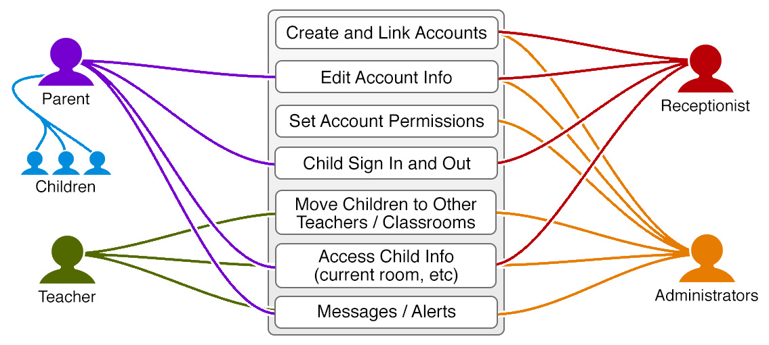

This standalone software system originated to help alleviate the accountability issues from a daycare center's day to day child organization routines. It offers a streamlined workflow for teachers and parents, with secure and simple sign in/out for the children.

Product Functionality
- Anyone will be able to sign the children in and out by using a username and password through the application. Once logged into the application there will be a sign in/out children option. The user chooses that option and selects the appropriate choice of in or out. The children’s information will be automatically placed into or removed from the application and saved with a timestamp for record keeping purposes.
- The user will also have the option to use a RFID tag to sign the children in or out. It will store the account information that will allow a faster option for the checking in and out process.
- The parent client can use the Android phone app or Android tablet. The will still have the option to use the main lobby terminal.
- The added child will be assigned, in the system, to the appropriate classroom and teacher. When the parent needs to pick up the child they will have an accurate location in the day care facility.
- Inside the application, the parent can update any notes for the child. They can add anything of importance such as any illness the child may have, medications and administration the child needs, and any other special attention item. Also, they can view any notes the teacher may have left for their child and any overall class notes.
- They will receive notifications that were sent out from the day care in the form of a push notification or an email; the option will be chosen by the parent.
- Parents will receive reminders to update their personal information for annual registration. This can be accomplished in the app.
- There is an option to add or change payment methods and make payment if the parent chooses.
- The teacher, when logged in, will have a view of every child that has been signed in to the day care and is assigned to their class. This can be used for roll call whenever needed.
- If the day care needs to move a child between classes, the they will be able to select the child and choose which class to move them to. The other teacher’s list will then update with the child added to their classroom list.
- If a child has been signed out of the class it will notify the teacher through a push notification. This will let the teacher know the parent is there and can respond accordingly.
- If a child has any medications to take throughout the day, it will notify the teacher at the appropriate time with how to administer the medication, the medication name, and dose.
- Also, if a parent has left any notes about the child, when the child is signed in, the teacher will get the note through a push notification so they can read it before class starts.
- Inside the app, only available to teachers and administrators, will be an option to create a message to be sent to the entire classes’ parents. This will allow them to update on any events or remind parents about anything relevant to the day care class.
- The list of the students will each have an option for the teacher to send a message to just that one student’s parent.

Users and Characteristics

Users are listed in order from least important to most important:

Main Lobby Access:
- Allows anyone to sign the children in and out by using a username and password through the application. Once logged into the application there will be a sign in/out children option. The user chooses that option and selects the appropriate choice of in or out. The children’s information will be automatically placed into or removed from the application and saved with a timestamp for record keeping purposes.
- The user will also have the option to use a RFID tag to sign the children in or out. At the Main Lobby Terminal the tag will be read and it will automatically add or remove the children based on the current status of the child without the need to actually sign in to the account or choose any option.
- Another option on the Main Lobby Terminal after the parent signs in will be to view the child’s current classroom location. If the parent needs to pick up the child they will have an accurate location in the day care facility.
- Inside the application, the parent can update any notes for the child. They can add anything of importance such as any illness the child may have, medications and administration the child needs, and any other special attention item.
Parent Client
- The parent client can use the phone app on their own personal phone versus using the main lobby terminal.
- They will receive notifications that were sent out from the day care and can see the current room their child/children are in. If a child switches classroom they will be able to see the change.
- They can add notes for the day care and teacher about anything that is relevant to their child while they are attending. Also, they can view any notes the teacher may have left for their child and any overall class notes.
- Parents will receive reminders to update their personal information for annual registration. This can be accomplished in the app.
Teacher Client
- The application will be able to run on Android tablets or cellular phones.
- The teacher, when logged in, will have a view of every child that has been signed in to the day care and is assigned to their class. This can be used for roll call whenever needed.
- If the day care needs to move a child between classes, the teacher will be able to select the child and choose which class to move them to. The other teacher’s list will then update with the child added to their classroom list.
- If a child has been signed out of the class it will notify the teacher through a push notification. This will let the teacher know the parent is there and can respond accordingly.
- If a child has any medications to take throughout the day, it will notify the teacher at the appropriate time with how to administer the medication, the medication name, and dose.
- Also, if a parent has left any notes about the child, when the child is signed in, the teacher will get the note through a push notification so they can read it before class starts.
- Inside the app, only available to teachers and administrators, will be an option to create a message to be sent to the entire classes’ parents. This will allow them to update on any events or remind parents about anything relevant to the day care class.
- The list of the students, the teacher has access to, will each have an option for the teacher to send a message to just that one student’s parent.
Receptionist/Staff Client
- Responsible for adding parents and children to the system with the needed information. Will be approved by administrative client.
- If there needs to be a change to the children’s or parent’s information, they can change it for them.
- If there is a problem with checking a child in or out, the staff can do it for the parent.
- At any point in time, they can see where the child is currently and any information the child might have.
Administrative Client
- Ability to add, edit, remove, or view all content within the application.
- Any of the options for functions that any user can execute, the administrative client will be able to use as well.
- Responsible for reviewing new staff, teacher, and parent user accounts and changing account rights and permissions accordingly.

Operating Environment
<Describe the environment in which the software will operate, including the hardware platform, operating system and versions, and any other software components or applications with which it must peacefully coexist. In this part, make sure to include a simple diagram that shows the major components of the overall system, subsystem interconnections, and external interface
TO DO: As stated above, in at least one paragraph, describe the environment your system will have to operate in. Make sure to include the minimum platform requirements for your system. >

In order for the application to run on an Android device, the device must have the Android OS 4.0.3., Jelly Bean, or newer. Any system that has an operating system older than Jelly Bean will be unable to download or use the application as is.

Design and Implementation Constraints

- Time constraints.
A large constraint of this project is the predetermined time schedule we have. A large percentage of that time will be taken by documentation, leaving us with only about a month to develop the actual software. Many things can stem from this. There are several features that we would like to include, but the time simply won’t allow it. We are planning to build around the possibility that we may run out of time, so we will get a working product and add the features that the time allows.
- Some staff unfamiliar with development aspects.
Our staff has different strong points, which could be considered a constraint. A variety of skill sets is valuable for covering different areas as long as the planning takes an individual’s strengths into consideration. However, the team could run into efficiency issues if a member is assigned to develop an aspect of the software that they are unfamiliar with. They will have a learning curve which ends up ‘wasting time’ on a project with strict time constraints.
- Security.
Due to time constraints, the security methods used for this software system may be limited to encryptions and API keys. We will use the best methods known to the group to create a product that is secure as possible. Like anything, security can always be improved.
- Payment systems.
This project was originally going to include a [simulated] payment system for tracking late payments and offering clean, fast payment options. We have decided to scrap the feature for the purposes of this product. It is not vital to the general idea and would not be worth the time required to develop.
- Psychology of user interfaces.
Our staff has a general understanding of the psychology behind creating intuitive user interfaces; the benefits received from deep research on the subject don’t justify it for the needs of this project.

User Documentation
Administrative Functions

- Creating User Logins:
  - From the home screen, choose “Create and Approve Accounts”.
    - Information needed to set up staff and teacher login accounts:
      - First and last name of the staff personnel/teacher.
      - Social Security Number.
      - Email address.
    - Information needed to set up parent login accounts:
      - First and last name of parent.
      - Telephone number.
      - Social Security Number.
      - Email address.
      - Children’s information.
        - First name.
        - Date of birth.
        - Notes.
    - Information needed to set up Administrator accounts:
      - First and last name of administrator.
      - Social Security Number.
      - Email address.
  - The email address will be used as their login name. The user will not be able to change the login name to anything else.
  - A password will be assigned automatically. The user will have the option to change it when logged in to their account.

- Adding children:
  - From the home screen, scroll through the options and choose “Edit Account Information”.
  - A pop up dialog will ask “Please enter parent’s email address: “ and type in the appropriate information.
  - If the email address is not found it will display “Cannot find email address: “ and three options will appear, “Try different email address” or “Find by parent SSN” or “Cancel”.
    - “Try different email address”: The screen will prompt for a new email address and, if it is found, will continue at step 4. If not it will repeat step 3.
    - “Find by parent SSN”: The screen will prompt for a social security number and, if it is found, will continue at step 4. If not it will repeat step 3.
    - “Cancel” will return the user to the home screen.
  - When the parent is found, enter all of the child’s information in the respective blank areas for name, date of birth, notes, and medications.
  - Select the “Save” button to store the information or “Cancel” button to remove and go back to the home screen.

- Viewing classroom assignments:
  - From the home screen, choose the option “Classroom Assignments”.
  - Choose the particular teacher’s name from the list.
  - The home view for that particular teacher will now be viewable. All teacher functionality will be available to use.

- Editing child’s information:
  - Choose the “Search for Child” option from the home screen.
  - Type in the child’s name and choose search.
  - If there is more than one child with that name then it will display all of the possible results with their picture. Choose the appropriate child and edit any of the information that you need changed.
  - Select the “Save” button to store the information or “Cancel” button to remove and go back to the home screen.

- Edit parent’s information:
  - From the home screen, scroll through the options and choose “Edit Parent Information”.
  - A pop up dialog will ask “Please enter parent’s email address: “ and type in the appropriate information.
  - If the email address is not found it will display “Cannot find email address:“ and three options will appear, “Try different email address” or “Find by parent SSN” or “Cancel”.
    - “Try different email address”: The screen will prompt for a new email address and, if it is found, will continue at step 4. If not it will repeat step 3.
    - “Find by parent SSN”: The screen will prompt for a social security number and, if it is found, will continue at step 4. If not it will repeat step 3.
    - “Cancel” will return the user to the home screen.
  - When the parent is found, edit all of the necessary information.
  - Select the “Save” button to store the information or “Cancel” button to remove and go back to the home screen.

Teacher Functions

- Moving a child to another classroom:
  - Click on the appropriate child’s picture from the home screen.
  - Choose the option to “Move to another classroom”.
  - Then a list of all other classrooms and teachers will be available to choose from. Choose the classroom that the child needs to move to.
  - Return back to the home screen and the child will no longer be available and will be available for the other teacher to view.

- Sending a notification to the entire class’ parents:
  - From the home screen, choose the action overflow button in the upper right corner.
  - Select “Notify All Parents” and a new screen will appear with a title and message.
  - Enter a title for the message and a brief, limit to 145 characters, message to be sent as a push notification. If the message needs to be longer, then follow the same steps as 1 and 2, but choose the “Send Class Email” option.
  - After you enter all the message information, choose send to finish or cancel if you need to erase everything and start over.

- Sending a notification to a single child’s parent:
  - From the home screen, choose the appropriate child by touching on the picture.
  - The next view will have all of the child’s information. Scroll down to the option “Notify Parent” and touch the option.
  - Enter a title and message, limit to 145 characters. If the message needs to be longer, then follow the same steps as 1 and 2, but choose the “Send Parent Email” option.
  - After you enter all the message information, choose send to finish or cancel if you need to erase everything and start over.

- Viewing child’s information:
  - From the home screen, choose the appropriate child by touching on the picture.
  - This will pull up a view of the child’s picture, full name, date of birth, notes from the parent, etc. There will be options to choose from below the child’s information.
  - If you need to see more information, touch the information section and it will bring up more details that is stored in the system.

- Adding a note to a specific child: (about that day’s activities and what happened)
  - Every day the teacher can add their notes about what activities happened or any other pertinent details that took place that day.
  - From the home screen, choose the appropriate child by touching on the picture.
  - Scroll down to the option “Daily Notes”.
  - Enter information into the Notes portion. It can be up to 350 characters and after you enter everything into the notes section press save. If you want to end and not save any changes press cancel.
Parent Functions

- Adding notes to a child:
  - From the home screen select “Add Note”, from the navigation drawer.
  - Then choose which child you want to add a note onto.
  - Choose a category of the type of note you are adding.
  - Fill in the note you want to add in the box labeled “Notes”.
  - Afterwards, touch the send button to complete or cancel to go back and not save anything typed.

- Viewing current notes, provided by the day care, for a child:
  - From the home screen select the child, from the action overflow button, you want to view.
  - This will display all notes added from day care personnel for that child.

- Changing personal information
  - From the home screen, touch the navigation drawer and choose “Account Information”.
  - This displays all the current information for the parent and children. At the top right corner, select the action overflow button and choose “Edit Account Information”.
  - The next screen will allow you to edit all of the information listed under Account Information.
  - After completing all the necessary edits, touch the button at the bottom that says “Save”.

- Signing children in or out:
  - From the main lobby access terminal, tap the NFC tag with NFC enabled Android phone to activate the Sign In/Out pop up dialog box.
  - All of the parent’s children will be listed with pictures and next to the pictures is an In/Out switch.
    - The most recent activity that took place is the part of the In/Out switch that will be highlighted. For example, if the child is being signed in then the “out” part of the switch will be highlighted.
  - Choose the correct side of the switch to activate a sign in or out. If the parent is signing in/out more than one child, the top will have an all button for both the in and out sides, so that they can change all the switches.
  - Once the choices have been made, click the send button at the bottom of the dialog box.
  - A toast message will appear notifying if the action was properly recorded with “Sign In Complete” or “Sign Out Complete”.

- Signing one child in or out:
  - From the home screen, touch the child from the action overflow button you want to sign in or out
  - Touch the navigation drawer and select “Sign In/Out”.
  - It will pop up a dialog box and choose to “Sign In” or “Sign Out”.
  - After you have chosen the option, it will say either “Sign In Complete” or “Sign Out Complete”.
  - If you have chosen to sign out, but do not have a sign in on record for that day then it will display “Must sign in first”. If so, then repeat steps 1 through 4.
  - If you have chosen to sign in, but already have a sign in on record for that day then it will display “Already signed in”. If this displays, repeat steps 1 through 4.

- Viewing child’s location:
  - From the home screen, touch the child from the action overflow button you want to view where they are currently located in the day care.
  - From the home screen, the news feed will contain only notes and updates related to that specific child. If there has been a change of location, it will show up on the feed.

Assumptions and Dependencies
<List any assumed factors (as opposed to known facts) that could affect the requirements stated in the SRS. These could include third-party or commercial components that you plan to use, issues around the development or operating environment, or constraints. The project could be affected if these assumptions are incorrect, are not shared, or change. Also identify any dependencies the project has on external factors, such as software components that you intend to reuse from another project.
TO DO: Provide a short list of some major assumptions that might significantly affect your design. For example, you can assume that your client will have 1, 2 or at most 50 Automated Banking Machines. Every number has a significant effect on the design of your system. >

Specific Requirements

External Interface Requirements

User Interfaces
Teacher Interfaces:
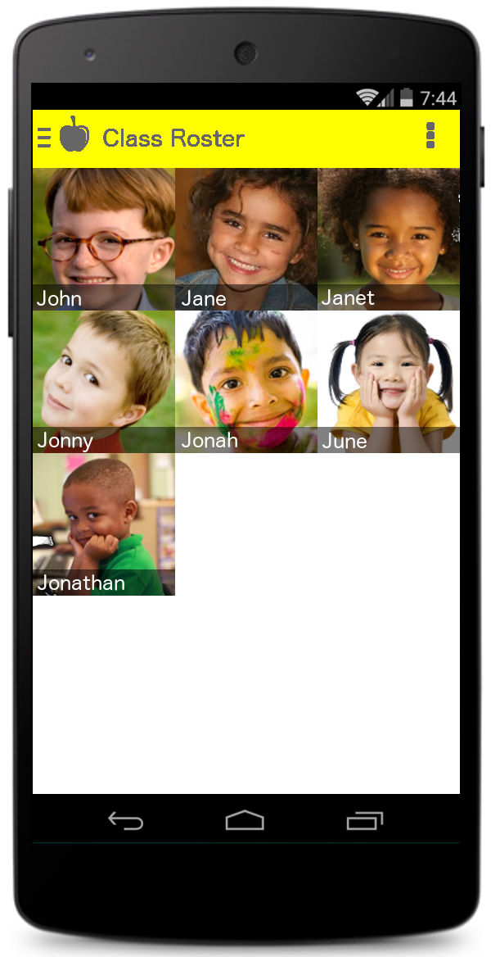

3.1.1.1. Teacher Client:
This is the home screen for the teacher. This will allow the specific teacher, logged in, to see all of the students that are assigned to their class. If a teacher had a student that was moved into her class by another teacher, it would update and add the student’s picture on the home screen.

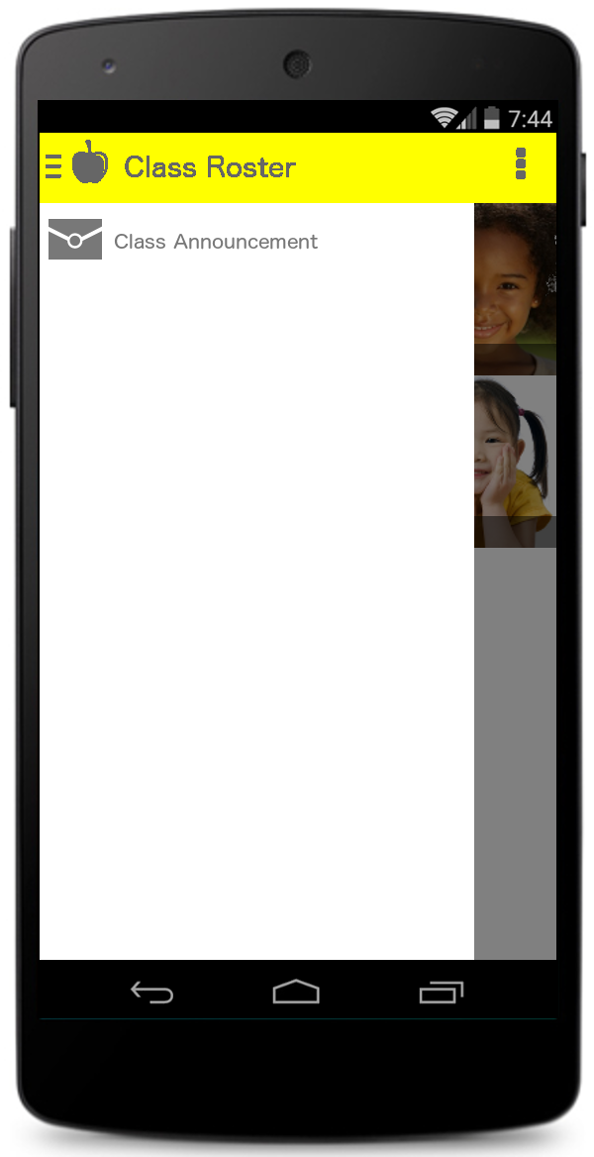

3.1.1.2. Class Announcement:
Clicking on the navigation drawer will allow the teacher to choose “Class Announcements”.
A new screen will appear with an option to select, at the top, for an email or note. Below that will be a section called “Title” and “Message”, where the teacher can input in the boxes accordingly and hit “Send” or “Cancel”.

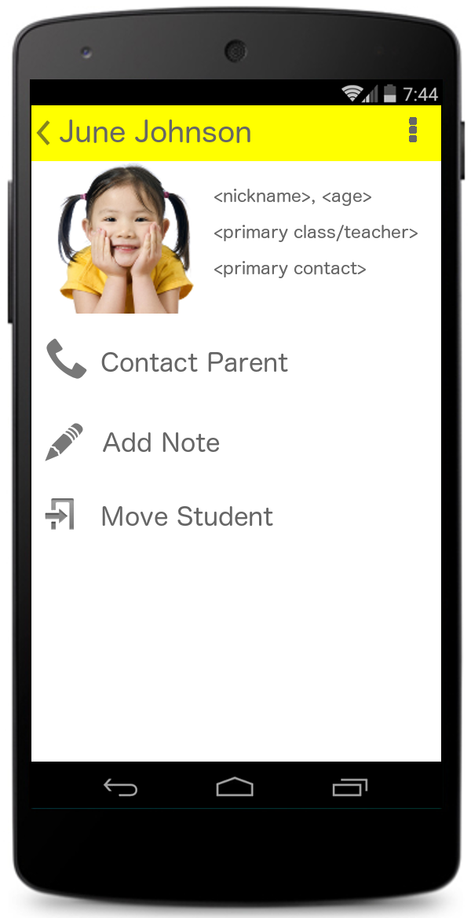

3.1.1.3. Child’s Information:
This includes a picture with a nickname, age, primary teacher, and primary contact. Also, it has buttons for contacting a parent, adding a note, moving a student, or reading notes on file.

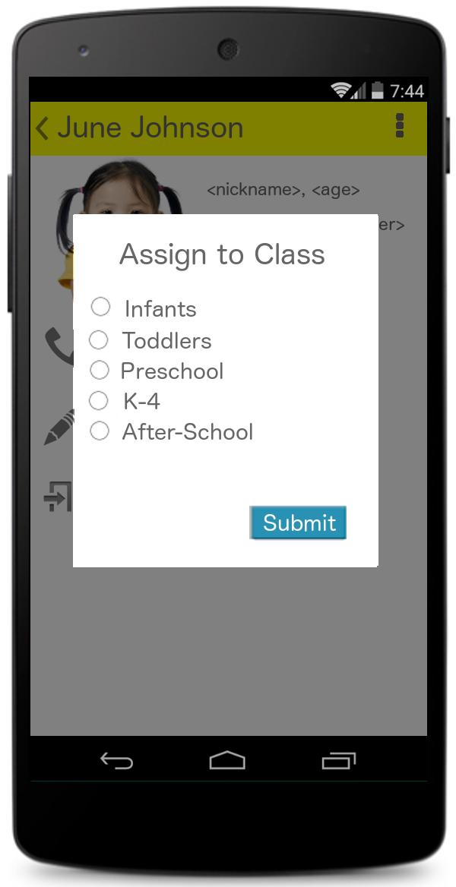

3.1.1.4. Moving a Child:
Pop-up dialog with options to pick which classroom to move the child is listed. There is a submit button to save the assignment.

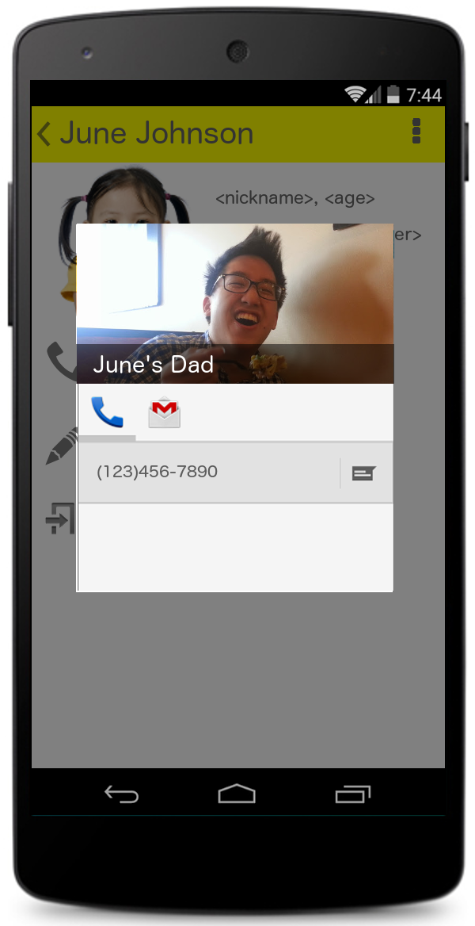

3.1.1.5. Contacting a Parent:
This displays the telephone number and picture (if available) of the parent. The user can touch the phone number to have it directly make a phone call.

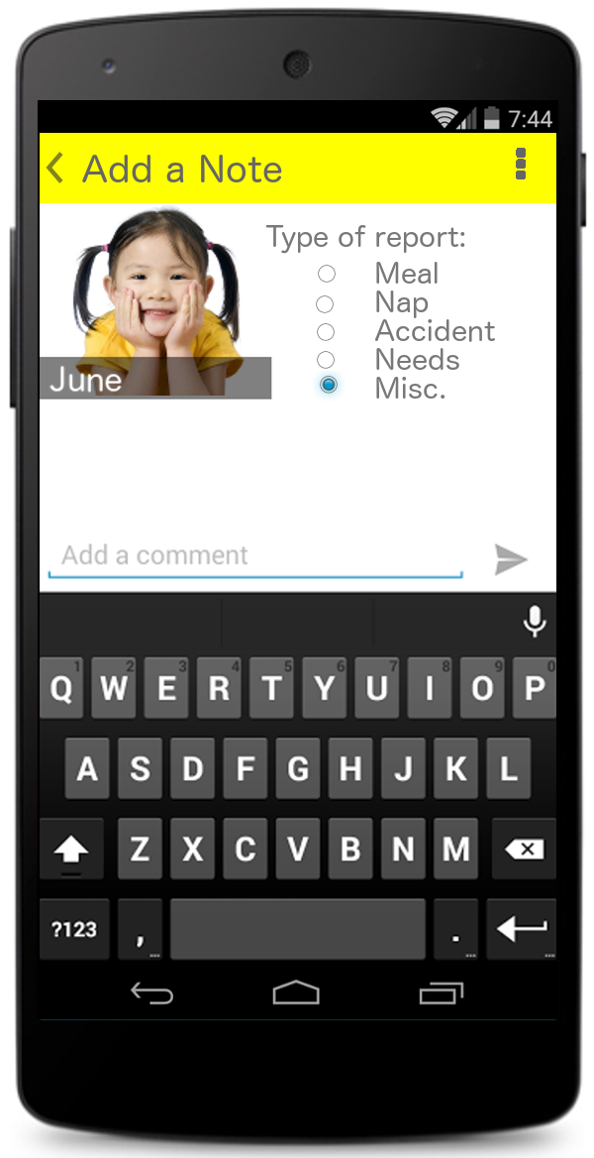

3.1.1.6. Adding Notes:
For the “Add a Note” screen, the user will be able to choose the type of note they are adding and the actual note itself. They can hit the send symbol to submit or back on their phone to cancel the note.

3.1.1.7. Reading Notes:
This display’s all notes the parent has sent to the teacher in the form of a news feed. The news feed will display the same as the parent’s news feed; Go to 3.1.1.8.

Parent Interfaces:
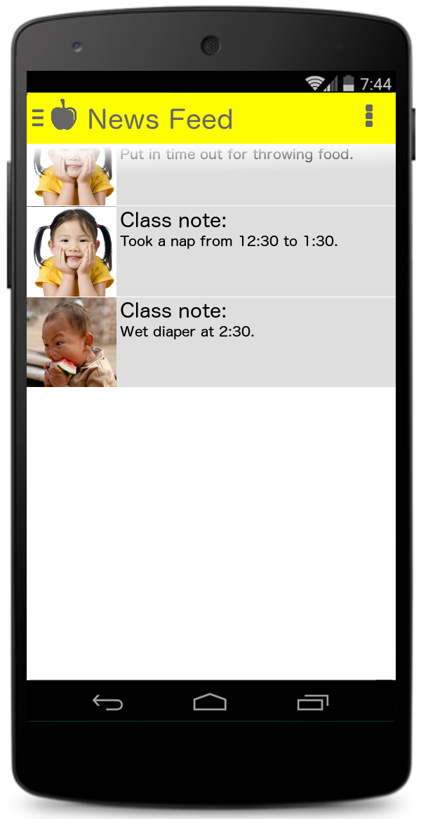

3.1.1.8. Parent Client:
This is the home screen for the parent user. This includes all updated notes from the teacher and also any notifications sent for the whole class. The news feed will also include an item for any classroom changes throughout the day. The navigation drawer will include the following:
- Add Note
- Account Information

<Screenshot>
3.1.1.9. Choosing a child:
Another screen will include pictures of the children a parent has enrolled. You reach this screen by choosing “Add Note”. This will allow the parent to choose which child they would like to add a note to.

3.1.1.10. Adding a Note:
Same screen as teacher view. Please see section 3.1.1.6.

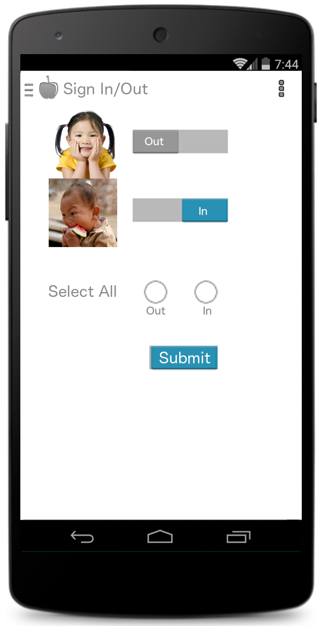

3.1.1.11. Sign In/Out:
This includes pictures with switches to choose which children to sign in and out. It will also have the option to sign all kids in or all kids out, followed by a submit button.

<Screenshot>

3.1.1.12. Account Information:
A list of all the account information on the parent and child will be visible. The parent can choose any available item that is not grayed out and update it at any time. If the parent has changed something, a submit button will be available to save all changes.

Administrator Interface:

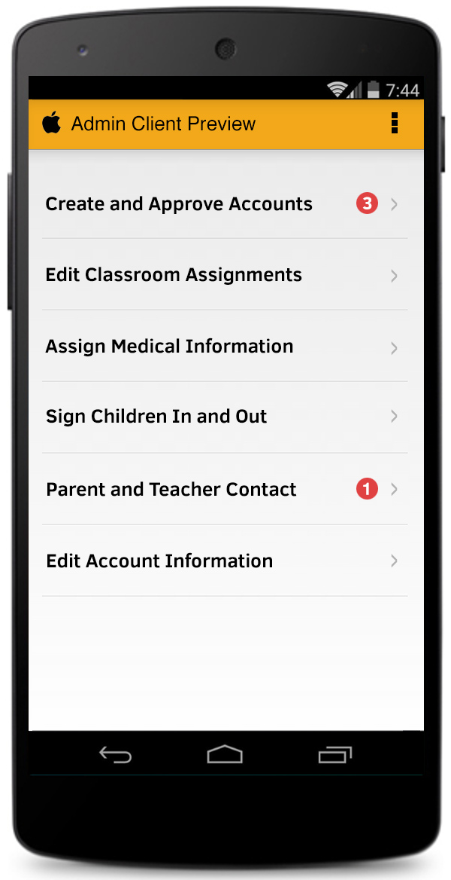

3.1.1.13. Admin Client:
The home screen will list all available options to any parent user or teacher user. Also, it will have a section to put in any medical information for a specific child. The option to create accounts and edit accounts will be included.

Staff Interface:

3.1.1.14. Staff Client:
The interface will look the same as the administrator interface except for the option to Approve Accounts and Assign Medical Information will not be available.

Hardware Interfaces
<Describe the logical and physical characteristics of each interface between the software product and the hardware components of the system. This may include the supported device types, the nature of the data and control interactions between the software and the hardware. You are not required to specify what protocols you will be using to communicate with the hardware, but it will be usually included in this part as well.
TO DO: Please provide a short description of the different hardware interfaces. If you will be using some special libraries to communicate with your software mention them here. In case you have more than one hardware interface divide this section into subsections.>

Software Interfaces
<Describe the connections between this product and other specific software components (name and version), including databases, operating systems (Windows? Linux? Etc…), tools, libraries, and integrated commercial components. Identify the data items or messages coming into the system and going out and describe the purpose of each. Describe the services needed and the nature of communications. Identify data that will be shared across software components. If the data sharing mechanism must be implemented in a specific way (for example, use of a global data area in a multitasking operating system), specify this as an implementation constraint.
TO DO: The previous part illustrates some of the information you would usually include in this part of the SRS document. To make things simpler, you are only required to describe the specific interface with the operating system.>

Communications Interfaces
<Describe the requirements associated with any communications functions required by this product, including e-mail, web browser, network server communications protocols, electronic forms, and so on. Define any pertinent message formatting. Identify any communication standards that will be used, such as FTP or HTTP. Specify any communication security or encryption issues, data transfer rates, and synchronization mechanisms.

TO DO: Do not go into too much detail, but provide 1-2 paragraphs were you will outline the major communication standards. For example, if you decide to use encryption there is no need to specify the exact encryption standards, but rather, specify the fact that the data will be encrypted and name what standards you consider using. >

Functional Requirements
3.2.1. Shared Functions:
- Sign in:
  - For the specific child, it adds the child into the system and places them as an active view for the teacher for whom the child is assigned. Also, a current date and time stamp is recorded and saved into a database for use in determining fees charged to the parent.
- Sign out:
  - Removes the child from the assigned teacher’s view and records the current date and time stamp for the same purpose of allocating any fees associated with a late sign out.
3.2.2. Staff Functions:
- Creating new accounts:
  - Information needed to set up staff and teacher login accounts:
    - First and last name of the staff personnel/teacher.
    - Social Security Number.
    - Email address.
  - Information needed to set up parent login accounts:
    - First and last name of parent.
    - Telephone number.
    - Social Security Number.
    - Email address.
    - Children’s information.
      - First name.
      - Date of birth.
      - Notes.
  - The email address will be used as their login name. The user will not be able to change the login name to anything else.
  - A password will be assigned automatically. The user will have the option to change it when they are logged in to their account.
- Editing current accounts:
  - Information that can be changed:
    - First and last name
    - Email address
    - Telephone number
    - Children’s information
      - First name
      - Notes
- Teacher assignments:
  - Students need to be assigned to a specific teacher.
  - A teacher can have as many students as the day care approves.
  - A student can change teacher assignments unlimited amount of times and at any point in time of the day.
- Notifying a parent
  - Note
    - Choose the type of note from the following:
      - Meal
      - Nap
      - Accident
      - Needs
      - Misc.
    - Enter a message that is no more than 145 characters.
    - Must update in the news feed and if the parent chooses as a push notification.
  - Email
    - Enter a title for the message
    - Enter the desired message
    - Must be able to send the email message to the parent’s email address on file and sent from the day care’s email.
- Notifying a class
  - Sent to the parents of all of the children assigned to one teacher.
  - See “Notifying a parent” in section 3.2.2 subsection labeled “Note”.
- Viewing a child’s notes:
  - For every child, all of the notes a parent has left for the day care can be viewed as a news feed.
    - A series of cards that will show the type of note and the message of the note. See 3.1.1.8 for the specific layout of the news feed.
- Adding a note to a child:
  - Under the child’s account, add the appropriate note needed.
  - See “Notifying a parent” in section 3.2.2 subsection labeled “Note” for the layout of the note.
  - This will be used for any teacher or staff member of the day care and the parent can also see this note on their respective Android device.
3.2.3. Teacher Functions:
- Moving students:
  - A teacher can move a student to a different teacher at any time of the day.
  - Once completed it will be updated immediately for the new teacher and original teacher.
- Notifying a parent:
  - See “Notifying a parent” in section 3.2.2 and 3.1.1.3.
- Notifying a class:
  - See “Notifying a class” in section 3.2.2 and 3.1.1.2.
- Viewing a child’s notes:
  - See “Viewing a child’s notes” in section 3.2.2.
- Calling a parent
  - See 3.1.1.5.
3.2.4. Parent Functions:
- Adding a note to a child:
  - See “Adding a note to a child” in section 3.2.2.
- Viewing a child’s notes:
  - See “Viewing a child’s notes” in section 3.2.2.
  - This will be the default home screen for a parent user.
    - For more than one child of a parent, the parent can choose to only show notes and notifications for a specific child on the news feed. They will select the child through the action overflow button to filter the news feed.
- Updating Account Information:
  - The information a parent can change at any time will be the same as “Editing current accounts” in section 3.2.2.
  - When the parent user chooses to view their account information, the appropriate information available for change will always allow the user to change the information. The other information displayed will be “grayed out” and be unable to change. They must go through a staff or administrator to change any other information.
3.2.5. Administrative Functions:
- Includes all of the functions listed in “Staff Functions” in section 3.2.2.
- Approving accounts
  - Any account added needs to be reviewed for accuracy and approved. An administrative account does not need to be reviewed because it will be added by a current administrator only.
  - Set the appropriate permission to one of the following:
    - Staff
    - Parent
    - Teacher
- Creating an administrative account
  - Information needed to set up Administrator accounts:
    - First and last name of administrator.
    - Social Security Number.
    - Email address.
  - The email address will be used as their login name. The user will not be able to change the login name to anything else.
  - A password will be assigned automatically. The user will have the option to change it when logged in to their account.
- Changing account passwords
  - If any account user has forgotten their user password, the administrator can reset the password to a generated password. The user will then be able to change it to a different password after they login.
- Adding medications
  - With the appropriate medical information provided by the parents, the administrator will add the following information the any child:
    - Drug name
    - Correct dosage
    - Frequency
    - Administration method
    - Brief description of the physical drug
  - The frequency will be used to push a notification to the child’s teacher at the appropriate time with the rest of the information. This will let the teacher know exactly how to give the appropriate medicine to the correct child.

Behaviour Requirements

Use Case View
<A use case defines a goal-oriented set of interactions between external actors and the system under consideration. Since sometimes we will not be able to specify completely the behaviour of the system by just State Diagrams, we use use-cases to complete what we have already started in section 3.3.1.

TO DO: Provide a use case diagram which will encapsulate the entire system and all possible actors. Do not include detailed use case descriptions (these will be needed when you will be working on the Test Plan), but make sure to include a short description of what every use-case is, who are the actors in your diagram. For more information please refer to your UML guide and the MiniThermostat SRS example file.>

Other Non-functional Requirements

Performance Requirements
  - Actions that involve updating personal information will not take more than 10 seconds.
  - Moving children from one class to another should take at the most 10 seconds.
  - The result of adding a user to the system will take no more than 20 seconds.
  - All push notifications need to delivered within 5 minutes of the created notification.
  - Authenticating users with RFID may not exceed 5 seconds.

Safety and Security Requirements
    - Sensitive Account Information
Sensitive information stored for each account with be stored with a one-way encryption. Things like Social Security Numbers, passwords, etc, will be encrypted.
    - User Authentication
Passwords are never stored or compared in plain text. User IDs and API Keys are generated through encryptions of special strings that are unique to each account. Each device will require admin authentication and matching User ID and API Key. A user’s key fob will store their unique User ID and special authentication key, never their personal information or password.
    - Child Information
Information for each child is never stored in association with their names. Instead, the information is stored with unique Child IDs which are generated through methods based on the child’s parent account. This adds an extra layer of protection to sensitive information about each child, including their current classroom, medication notes, etc.

Software Quality Attributes
    - Usability
This software should be designed for a fast and efficient workflow that allows for quick adoption in many environments. The end user has a small learning curve through the use of intuitive user interfaces, resulting in improved usability.
    - Reusability
This software is efficient and reusable over time by keeping the usage history separate from current weekly, actions. Administrators will have the option to choose how long to keep usage history.
    - Interoperability
This software has the opportunity to tie into other systems through the use of the API. Some features could easily be converted into “public” APIs for other internal systems could tap into. If the pre-existing system offers some sort of API functionality, this software could also tap into that.
    - Reliability
The software should smoothly run on either a web server or local server. A local server would provide the most reliability since it would not require an active internet connection to interact with: in the event of an ISP outage, the system could still be access and modified. (For the ease of development and display of this project, we will be using a web server).

Appendix A – Data Dictionary

Appendix B - Group Log
<Please include here all the minutes from your group meetings, your group activities, and any other relevant information that will assist the Teaching Assistant to determine the effort put forth to produce this document>

